**MasterCard/Fiserv:**

Make sure the Master card file/Fiserv file have been generated for today and moved to the backup folder. If the file has not been moved then manually move it to the backup folder. Then follow up with the team to make sure the file has been processed.

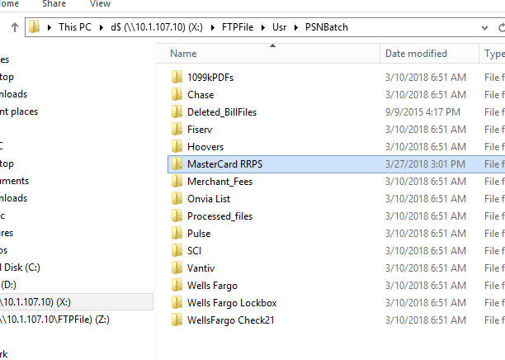

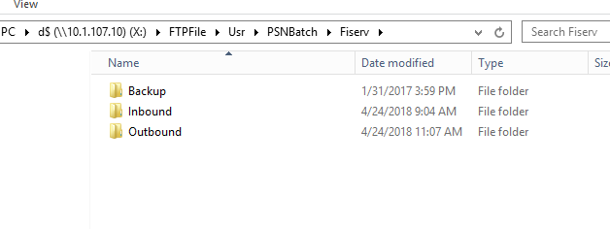

*It’s very important that the file is moved to the backup folder so it won’t get processed twice.